CPE186: Project 1 - PCI Arbiter Design

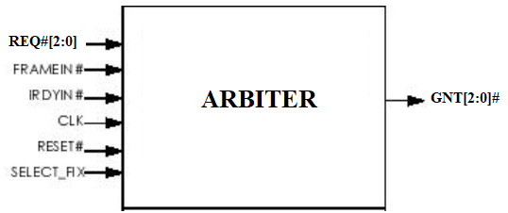

The PCI bus arbiter performs bus arbitration among multiple masters on the PCI bus. Suppose 3 bus masters reside on the PCI bus, as well as requests for the bus. One pair of request and grant signals is dedicated to each bus master. The PCI bus arbiter implements rotating priority (also called round-robin) scheme. In the rotating priority scheme, the requestor that is most recently granted the bus receives the lowest priority, while the requestor position next to it receives the highest priority. The remaining requestor receives subsequently lower priority based on its position.